|  |
| --- |
|  |
| User Guide |
|  |
|  |
| **Group-7** |
| **2013/12/10** |

|  |
| --- |
|  |

**DIRECTORY**

1. GUI 2

1.1 Welcome GUI 2

1.2 Root Loading GUI 2

1.3 Load Memory GUI 3

1.4 Set PC GUI 4

1.5 Simulator GUI 4

1.6 Console GUI 5

1.7 Virtual Keyboard 6

2. Initialize Program Load 6

2.1 Welcome 6

2.2 Set Memory 7

2.3 Set PC 7

2.4 Finish Initialization 7

3. Input Data 9

3.1 Input Memory 9

3.2 Input Data 10

4. Console Input 12

4.1 Input from console keyboard 12

5. Run 13

5.1 Run the program 13

1. GUI

All of these windows can change their languages according to your system language. So do not worry about language problems.

* 1. Welcome GUI

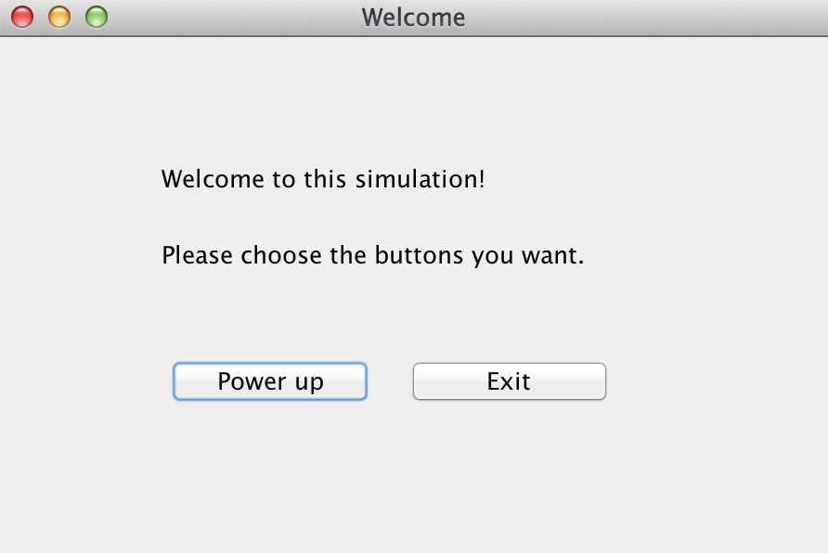

When you run this program, you first see this welcome window.

Button “Power up” is for you to start this simulator. When you click this button, there will be a guide to help you to initialize the data.

Button “Exit” is to exit from this program.

* 1. Root Loading GUI

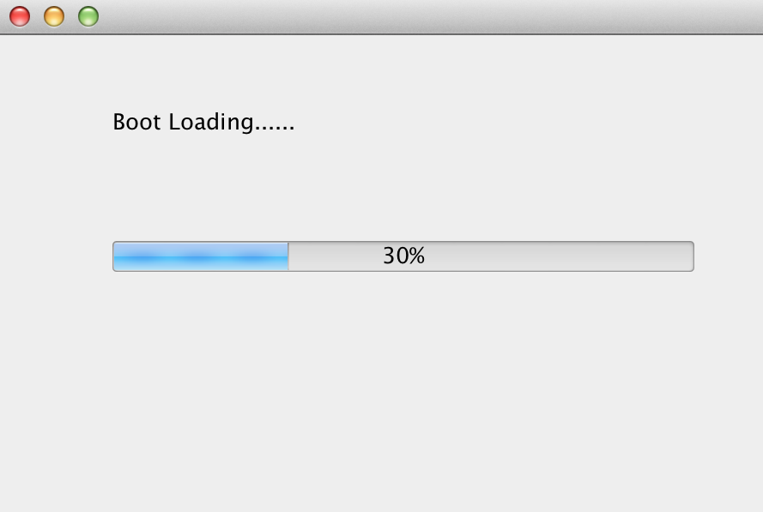

When you start this simulator, you will see this root loading window.

Please just wait until the root loads completely, and then you will see the loading memory window.

* 1. Load Memory GUI

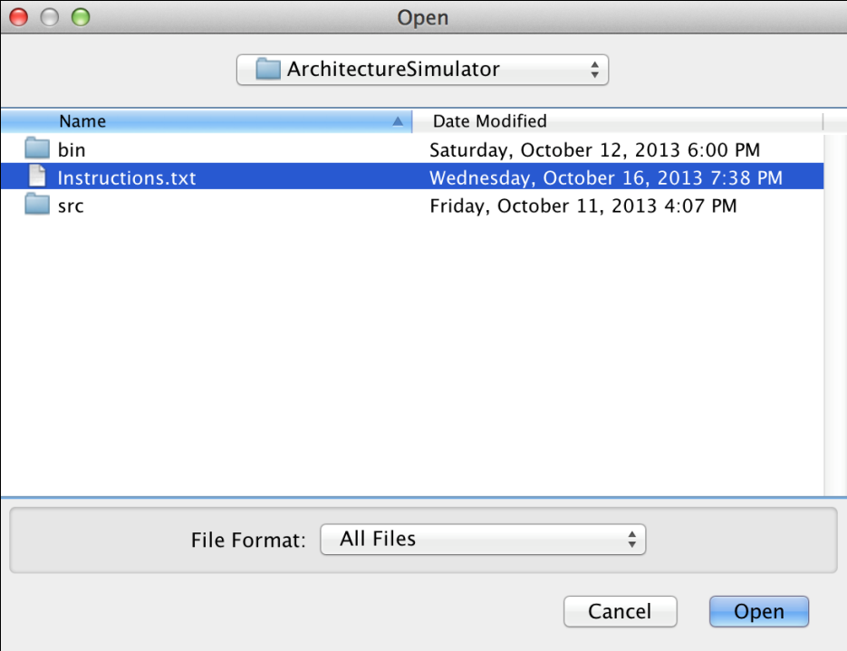

This window is for you to choose a file to load the memory into the simulator. The language of this window can be changed according to your system language.

Just choose the file you want, and click Button “Open”.

If you do not want to load the memory, please click Button “Cancel”.

* 1. Set PC GUI

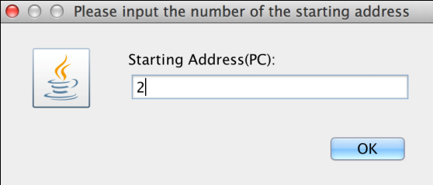

This window is for you to input the starting address (PC) into the simulator. The language of this window can be changed according to your system language.

Please input the number (e.g. 1, 2, 3), and then click Button “OK”.

* 1. Simulator GUI

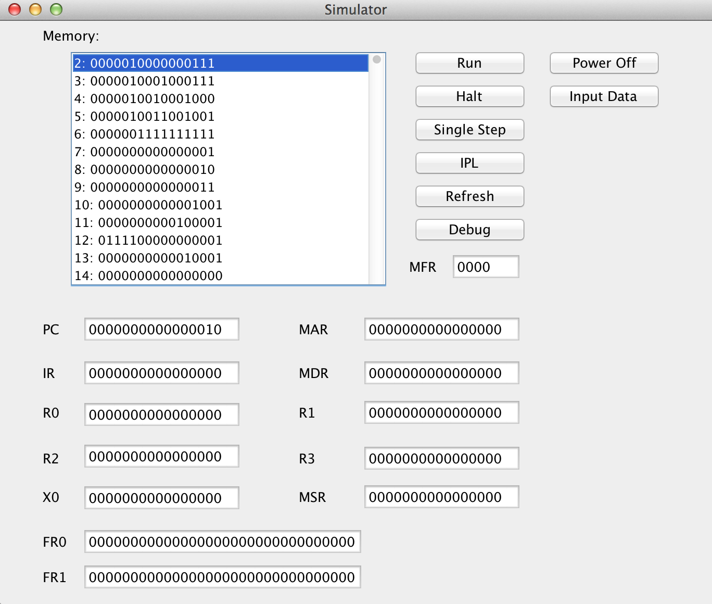

When you finish initializing, you will see this window.

Button “Run” is to run the program, and it will stop at the “HLT” instruction.

Button “Halt” is to stop the program.

Button “Single Step” is to finish a instruction according to PC.

Button “IPL” is to initialize program load.

Button “Refresh” is to refresh the window according to the result that this program gets.

Button “Debug” is to debug the program, and it will stop at the “HLT” instruction.

Button “Power off” is to power off the simulator, and it will close all the windows.

Button “Input Data” is to input data into the simulator. You are able to enter data into any of R0 – R3, besides you can also enter data into memory.

* 1. Console GUI

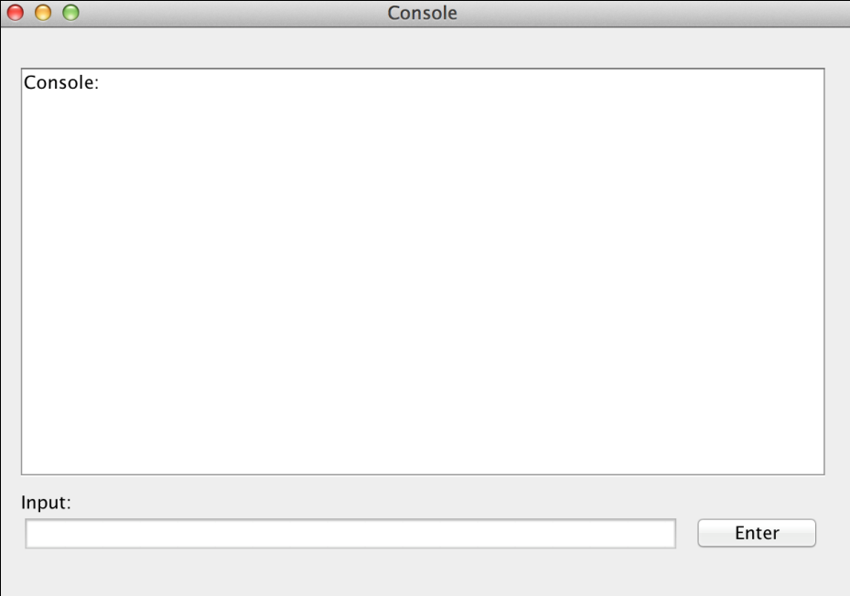

When you finish initializing, you will see this window.

You can see the console layout in the window.

You can input characters via the field on the bottom. Just input the character you want and click Button “Enter” or push the key “Enter” on your keyboard.

* 1. Virtual Keyboard

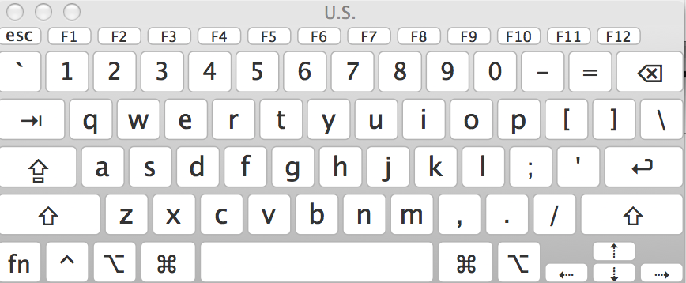

When you finish initializing, you will see this window. This virtual keyboard is changed according to your system.

This is a simulator of your physical keyboard. You can input via this keyboard. Attention! Please select the input area of the console first.

You can use both this virtual keyboard and your physical keyboard.

1. Initialize Program Load
   1. Welcome



Click the Button “Power up” to start the initialization.

* 1. Set Memory



Choose a memory file to load.

* 1. Set PC



Input the PC number.

* 1. Finish Initialization



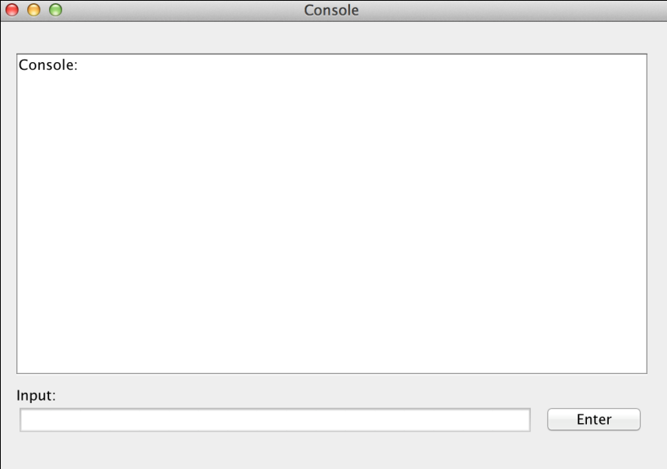



When the initialization finish, you can see both of these windows.

1. Input Data
   1. Input Memory

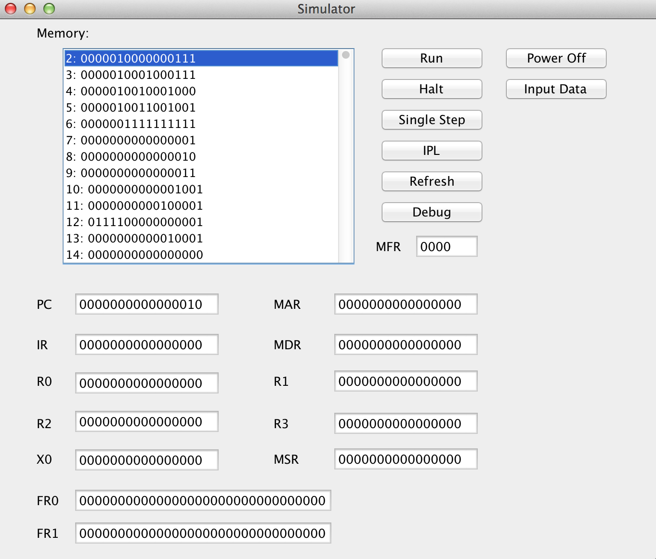

Click Button “Input data”, and you will see a window like following.

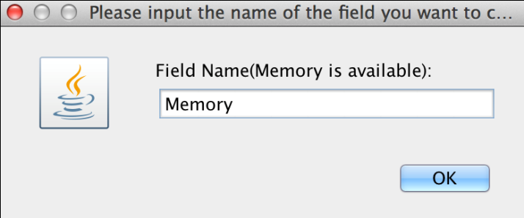

Input “Memory”, and click Button “OK”.

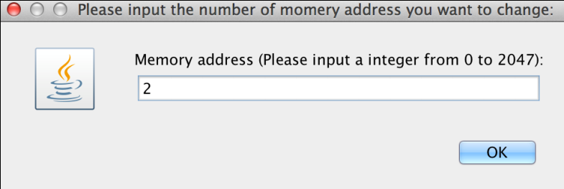

Input the address number you want to enter data into, and click Button “OK”.

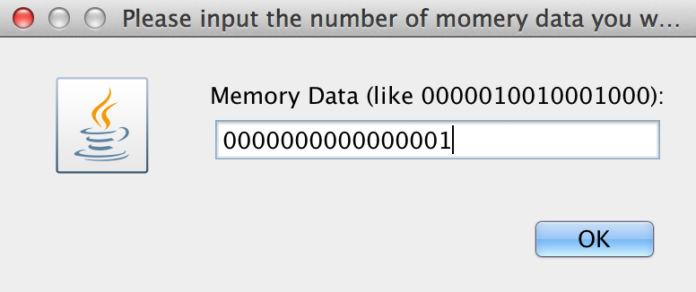

Input the data you want to enter, and click Button “OK”.

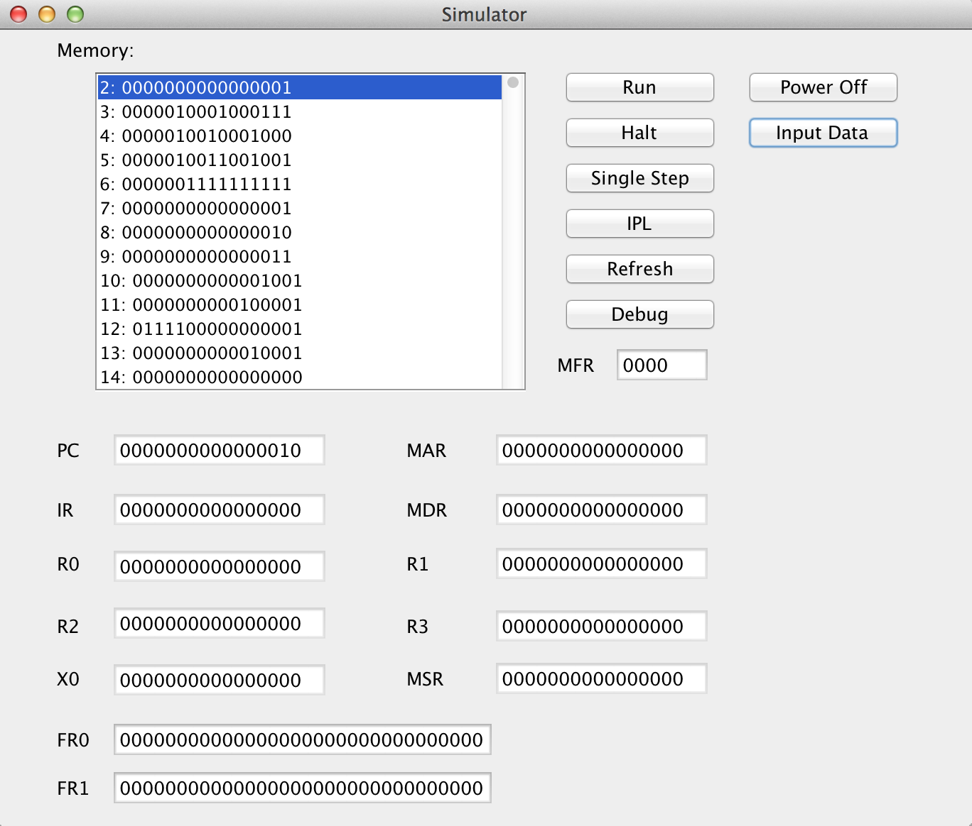

Congratulation! The data in the memory has been changed successfully.

* 1. Input Data

We will take PC as an example.

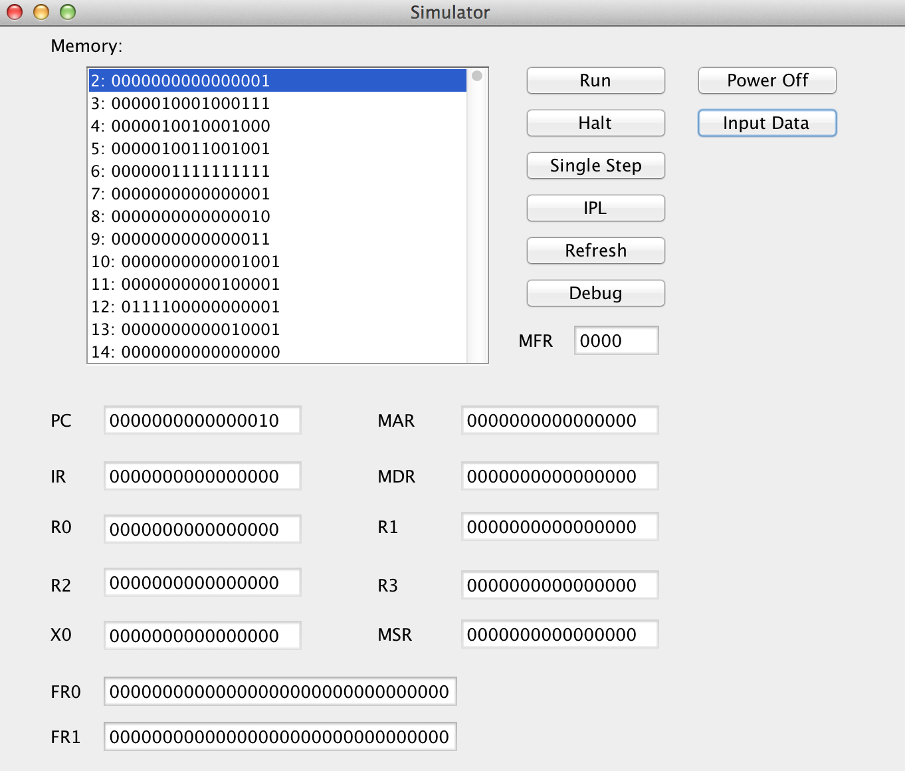

Click Button “Input data”, and you will see a window like following.

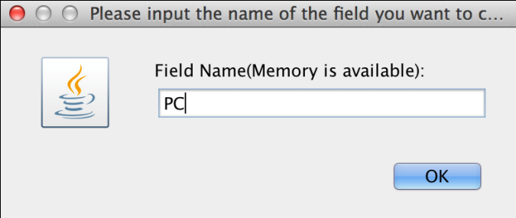

Input the field name you want to enter, and click Button “OK”.

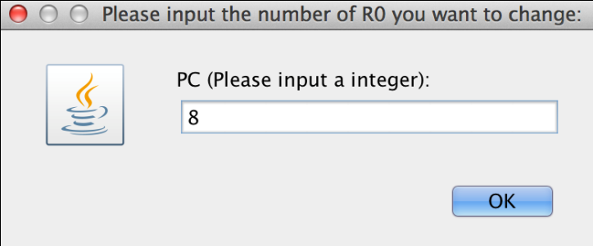

Input the data you want to enter, and click Button “OK”.

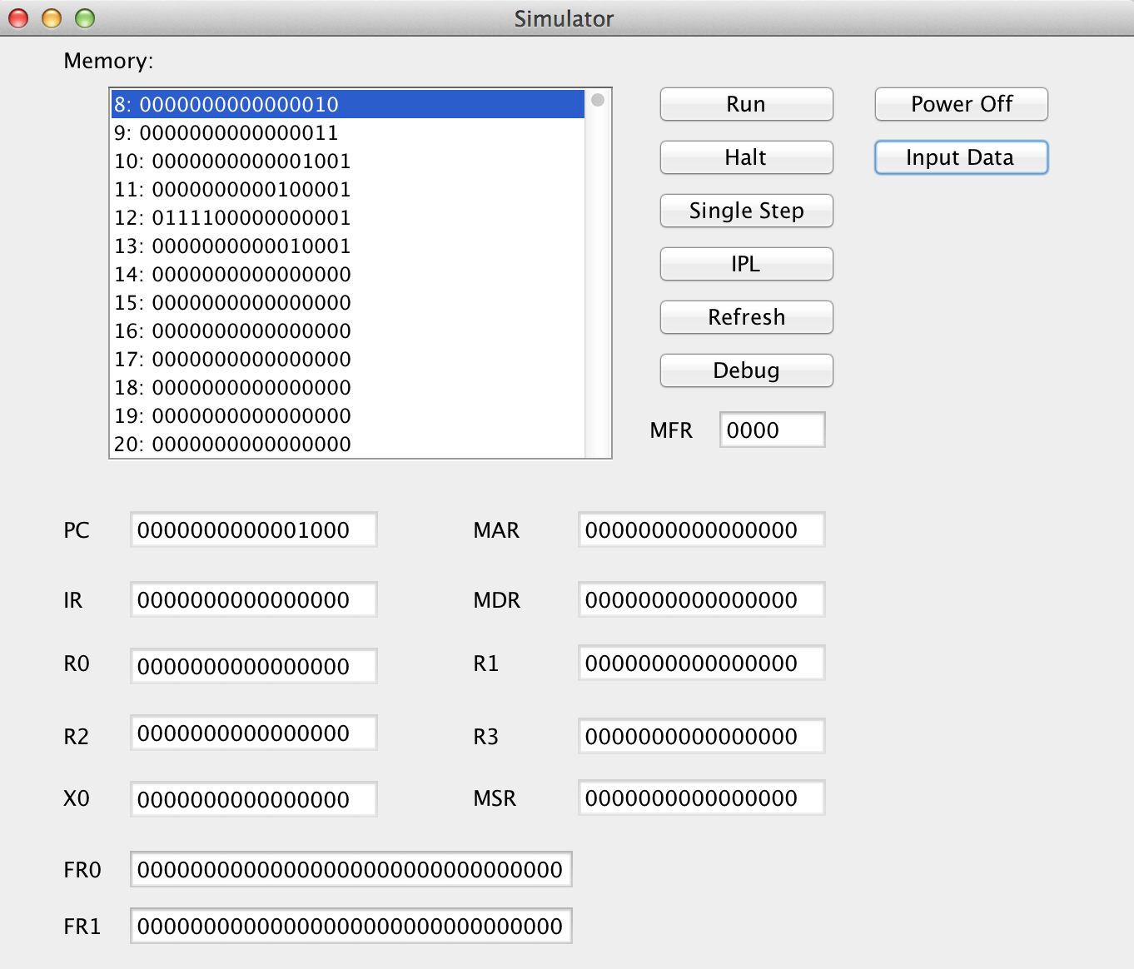

Congratulation! The data has been changed successfully.

1. Console Input
   1. Input from console keyboard

You can use both your physical keyboard and virtual keyboard. The virtual keyboard looks like following (There may be a little difference according to different systems.).



Choose the console input.

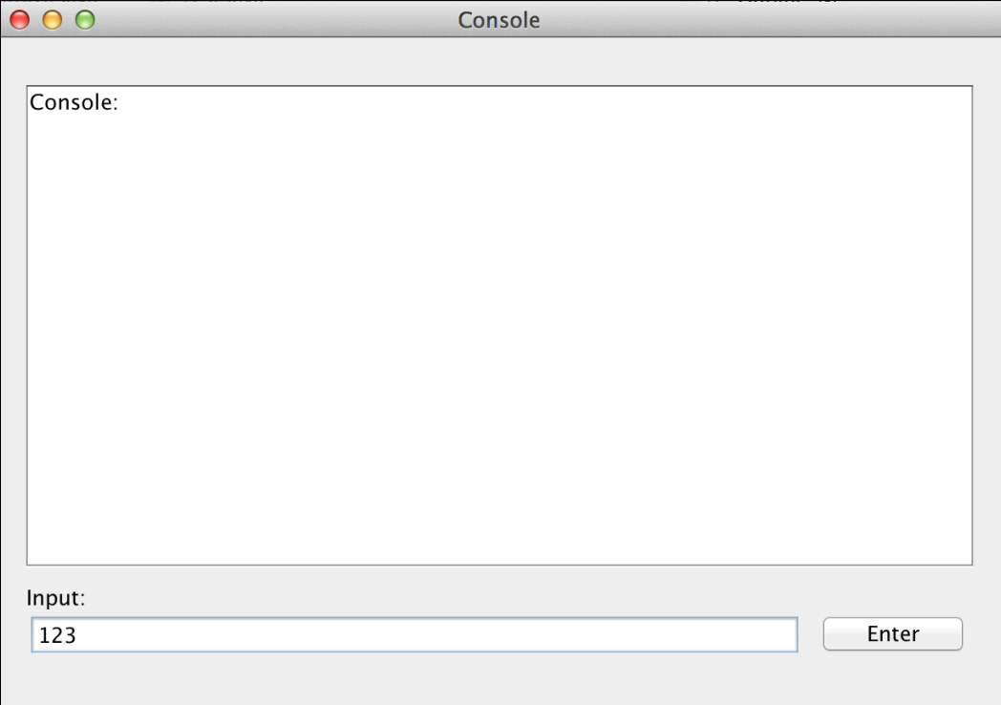

Input some characters like “123”.

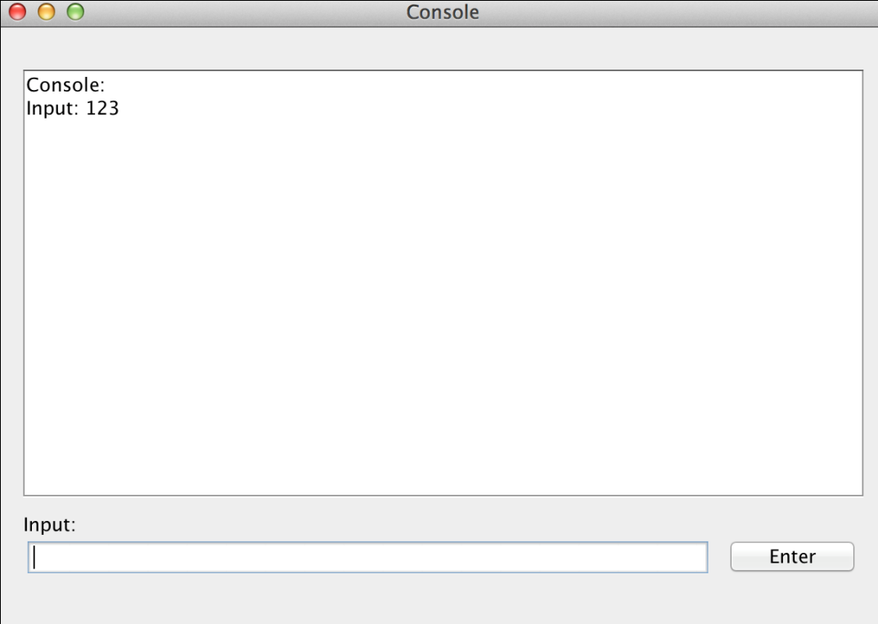

Click the Button “Enter” or press the key “Enter” to input the characters you type.

1. Run
   1. Run the program

When you finish the initialization and all data in this simulator are correct, you can see the window as following.

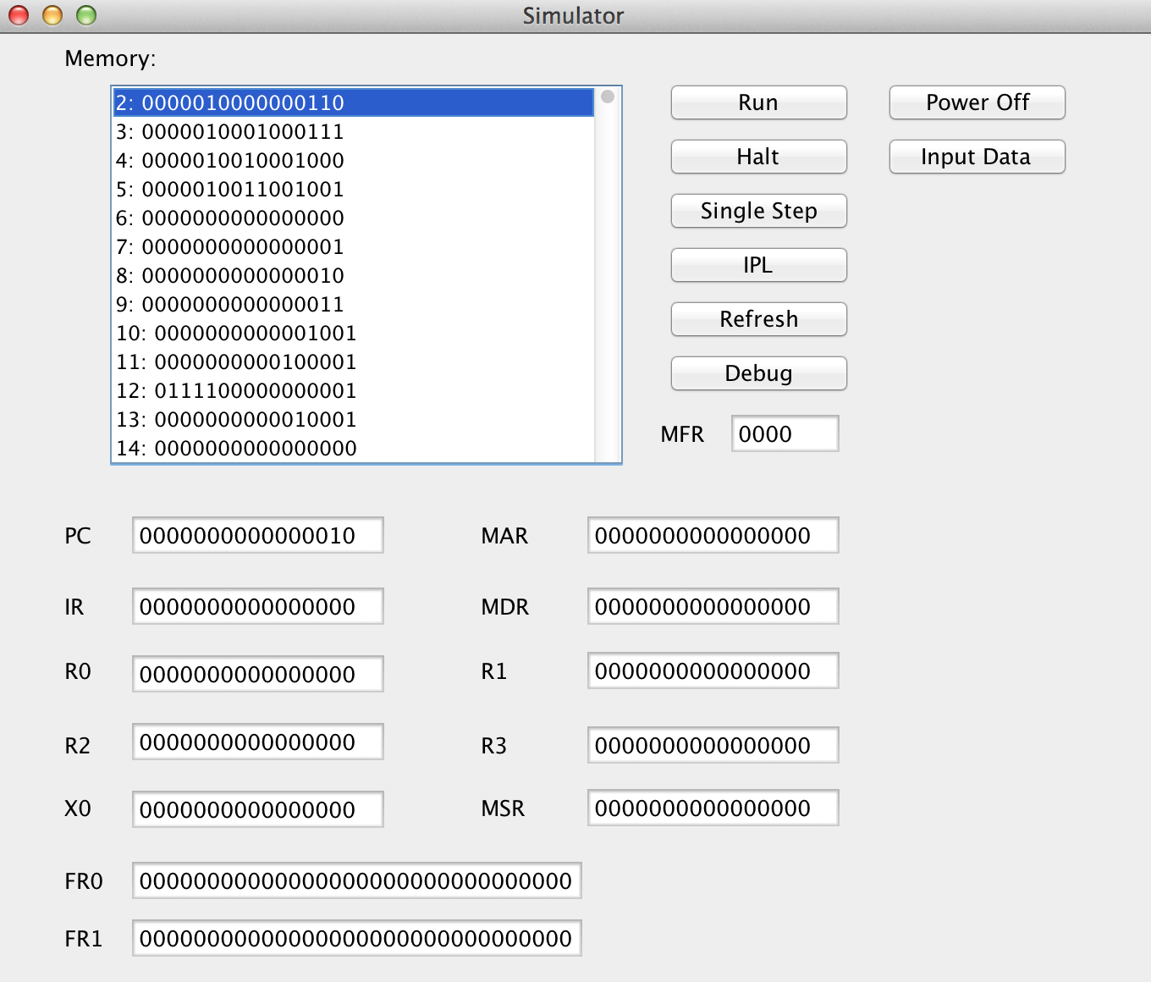

Then click Button “Run”, wait for a few seconds, and you can see the result of the program you run as following.

